**Primer on SentiStrength**

While LightSIDE requires training data, SentiStrength works without training data, but is not particularly smart about calculating sentiments (as it simply adds weights of individual words to produce a positive and a negative score for each message).

**SentiStrength**

The problem with SentiStrength is that it adds up weights (+5 to -5) of words to get a sentiment score. Main advantage is that it works without training data and gives one positive and one negative score per post or message.

Download the (i) dictionaries and (ii) software from <http://sentistrength.wlv.ac.uk/download.html>. When you run SentiStrength it may ask you where the data files are located. Once you specify this location, you are all set.

To get a clean, easily readable output, I suggest you uncheck “Report Classification Rationale” and “Report Translation” under “Reporting Options”. Do this before you ask SentiStrength to analyze the social mentions.

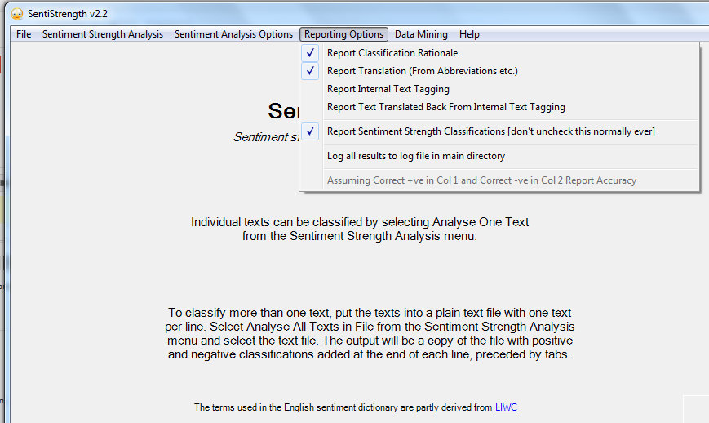

After unchecking the options.

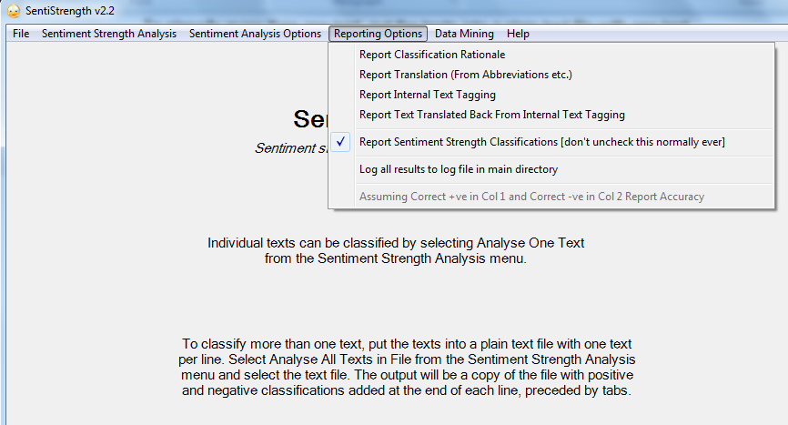

Also you may want to delete the first row in the CSV file containing the text – this row contains the headers.

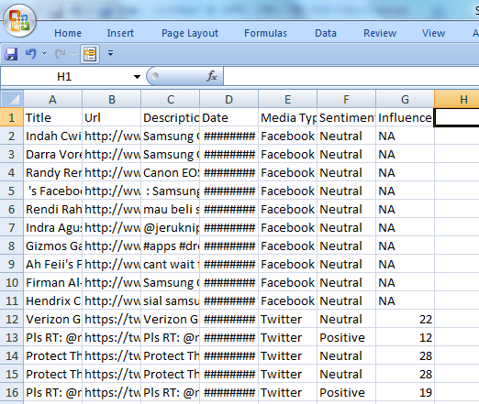

Save the CSV file as a tab delimited text file in Excel. Now choose “Amalyze ALL Texts in File” under Sentiment Strength Analysis in SentiStrength.

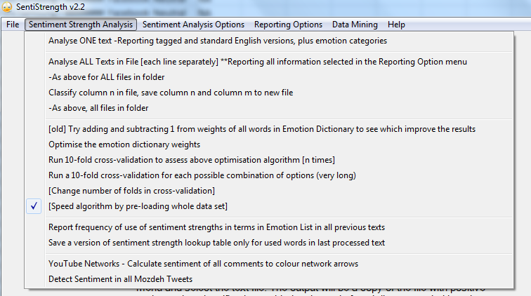

Choose the text file you created and SentiStrength asks you which column contains the text (in most cases the response will be “1”)

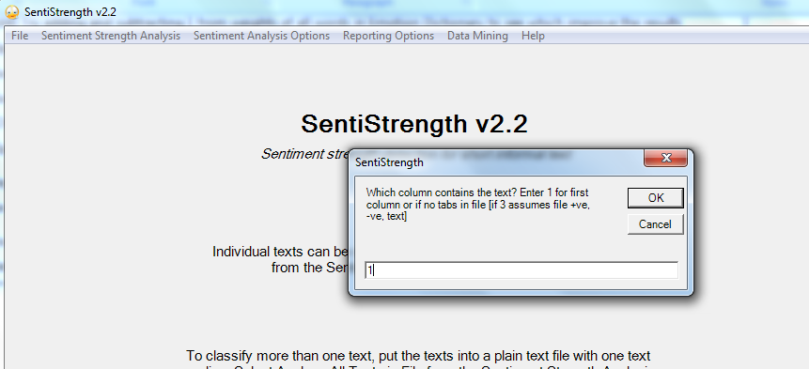

SentiStrength adds “+ Results” to the name for the output file. Also make sure that the original file with the mentions has been shut down by Excel (otherwise SentiStrength will not work).

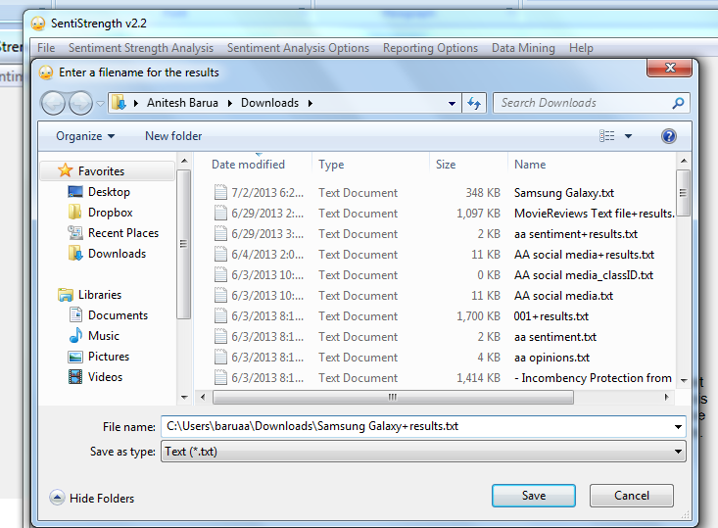

SentiStrength is quick in doing its job. Now open the output file with Excel, which should recognize the tab delimited nature of the output file. It takes you through a bunch of steps (just agree and continue clicking on “next” until you see “finish”) as shown below before opening the file with a clean output.

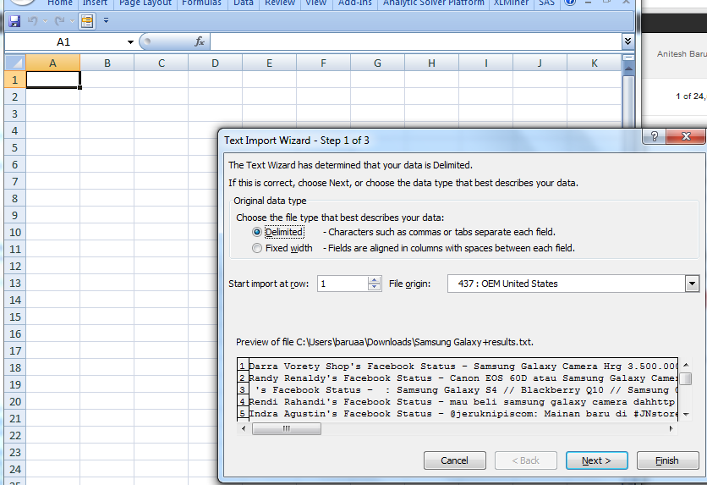

Generally just clicking on Finish above should produce a clean output. If not, continue as shown below:

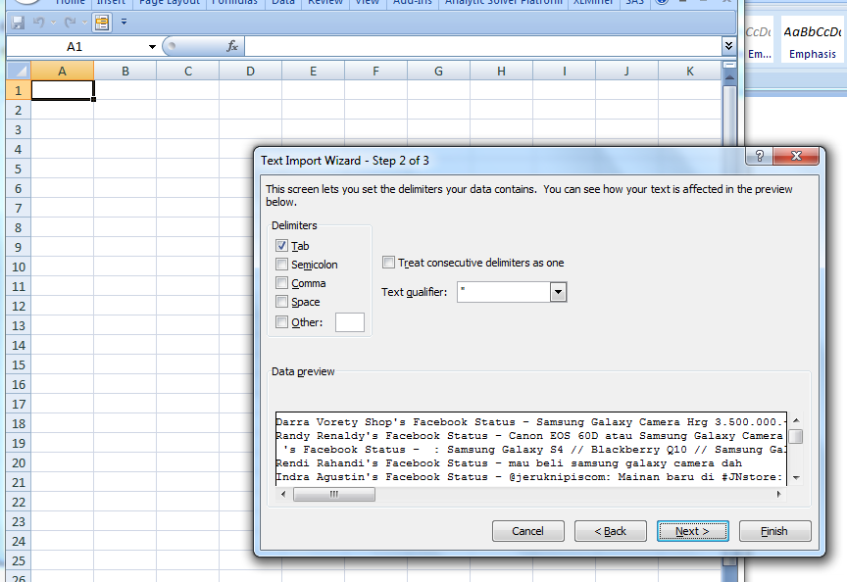

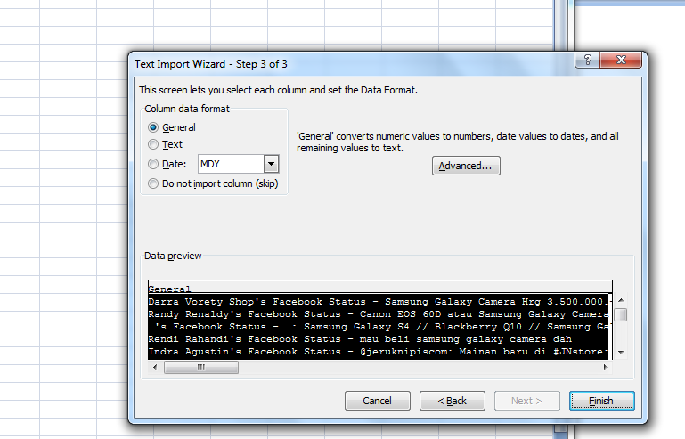

SentiStrength creates two columns (H and I in the screenshot below). It inserts a positive sentiment in the first column and a negative in the latter. The sum would be the net sentiment. Note that the Trackur sentiment in column F matches the SentiStrength sentiment reasonably well (at least in this case).

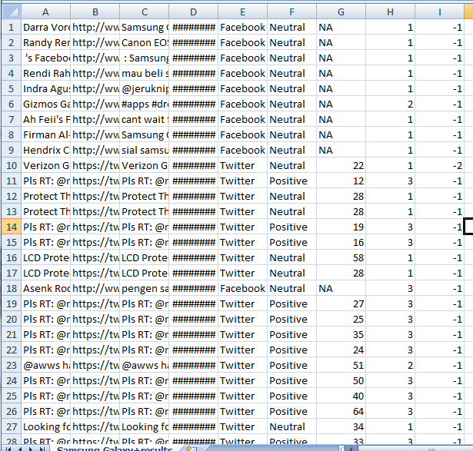

Now after some spot checks if you want to tweak the weights of individual words to improve the sentiment analysis of SentiStrength, I recommend that you check “Report Classification Rationale” under “Reporting Options” (you had unchecked this option earlier to get a clean output). Now run the analysis again, and this time there will be an extra column created by SentiStrength which shows how it calculated the sentiment from weights of individual words. I have attached the file where this rationale is shown in column J. The word weights used are shown, and if you think (after spot checks) that some words should have different weights from the defaults used by SentiStrength, you can change them in the EmotionLookup text file you downloaded when installing the software (see below).

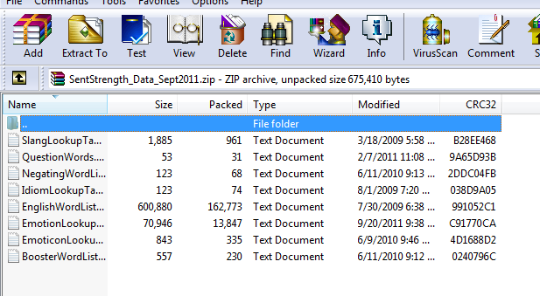

You can manually change the weights in the first EmotionLookup file. If you do so, make sure you reload the file into SentiStrength. You can do this by choosing “Reload all lookup tables used in emotion classification” under the File menu in SentiStrength.

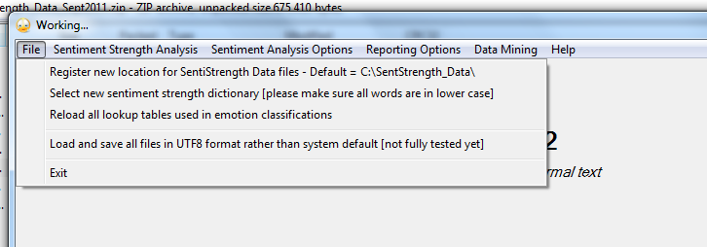

I haven’t had the time to try this out, but you should be able to add new words as well. To do so, you will have to add new words in the EnglishWordList file (in the same directory as the EmotionLookup file), and then add the words along with sentiment weights in the EmotionLookup file. Don’t forget to tell SentiStrength to reload these lookup files before doing any analysis. For more information, go to the website:

<http://sentistrength.wlv.ac.uk/>

**SentiStrength for Mac Users**

Please download the Java version from here:

<http://sentistrength.wlv.ac.uk/SentiStrengthCom.jar> (please copy and paste rather than clicking the link)

and use it with the text files extracted from this zip file

<http://sentistrength.wlv.ac.uk/SentStrength_Data_Sept2011.zip>

There is a brief manual online.

<http://sentistrength.wlv.ac.uk/documentation/SentiStrengthJavaManual.doc>

There is a bit of extra information for the Java version on the web site too. This is for academic use only.